**Broad-Phase Collision Detection for a Rigid Body Based Physics Simulation**

Sam Oates Teesside University School of Computing

**Abstract**

This paper aims to contrast and compare the benefits and draw backs of different broad-phase collision detection algorithms used within a real-time physics simulation.

**Introduction**

**The Problem**

Advanced physical simulation of many rigid bodies is a costly process to simulate in real-time. Close-Phase collision detection algorithms such as AABB (Axis aligned bounding boxes) or OBB (Object aligned bounding boxes) test against all rigid bodies within the scene, resulting in an O(n2) algorithm.

**Background**

Broad-phase collision detection algorithms are; for the majority based around some form of splitting the simulation world into smaller chunks. Splitting the simulation allows bodies within each chunk to only have to test against siblings that also reside in said chunk. This reduces the collision algorithm from O(n2) number of collisions to a much smaller easier to handle number of collisions. One type of broad-phase collision detection algorithms are based around a tree of data, such as; Binary space partition (BSP) trees, Quad trees, Octrees and K-d trees. Rigid bodies are then attached to branches (or nodes) of said trees. A commonly used type of broad-phase collision detection is the sweep and prune algorithm, which simply aims to remove rigid bodies that are definitely not colliding with one and other from narrow-phase collision detections.

**Binary Space Partitioning**

Given certain parameters, binary space partitioning is the method of recursively dividing a simulation world in two until said parameters are met.

BSP trees can be advanced by adjusting the tree at runtime as proposed by Rodrigo G. Luque in their paper Broad-Phase Collision Detection Using Semi-Adjusting BSP-trees [Luq05]. Luque suggests scheduling checks to re-evaluate the BSP tree. Should the BSP tree become unbalanced, several strategies to re-balance the BSP tree can be used. Rodrigo proposes altering cutting planes of the tree and re-structuring the tree based upon cost, potentially deferring the re-structure. Doing so can improve performance, however can also hinder the performance of the physics simulation due to the nature of re-evaluating the simulation world and moving data about the tree regularly.

Binary space partitioning is more commonly used with static data, such as graphical rendering and is still used within many modern graphical engines, however due to its less often used within dynamic physics simulations.

**Quad and Oct Trees**

A Quad tree is a tree where each node within the tree is sub-divided into four sub-nodes, where each of the sub-nodes are sub-divided into four and so on and so forth until a given parameter is met [Sam84]. This reduces the number of collision detections required within the physic simulation, as only bodies within the same sub-node need to be compared. Due to this, the number of rigid bodies within a node should never fall lower than two as a test between two rigid bodies is required.

Quad trees have the limitation of only splitting the simulation world into two dimensions. This is why this technique is generally used within two dimensional simulations and terrain rendering systems.

The three dimensional version of a Quad tree is an Octree [MW88]. The Octree similar to the Quad tree is split into sub-divisions, however rather than splitting into four sub-nodes the Octree is split into eight sub-nodes, covering three dimensions of virtual space rather than two.

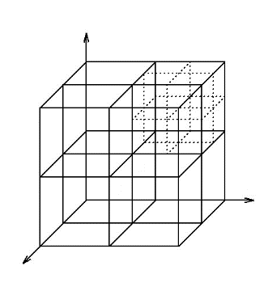**Sweep and Prune**

The Sweep and Prune technique is a pseudo-dynamic collision pruning algorithm which reduces three dimensional collision detection between AABBs into three separate one dimensional collision problems. Sweep and Prune is one of the most commonly used algorithms within broad-phase collision detection. It uses efficient pair removal as well as it not depending on the rigid bodies’ complexity.

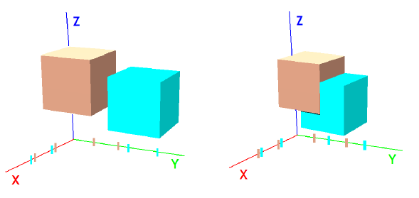

Figure 2: (Left) Non-overlapping sweep and prune (Right) Overlapping sweep and prune

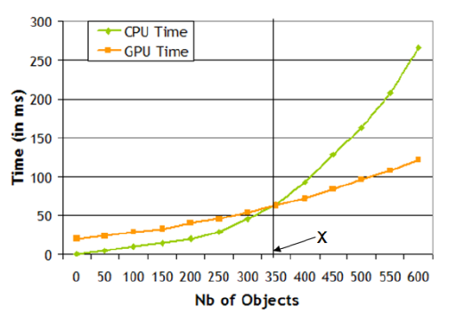Sweep and prune was developed by Baraff [BAR92] and implemented by Cohen et al. [CLMP95]. The technique improves upon an existing technique called sweeping plane, it does this by exploiting the temporal coherence existent within physics simulations. Knowing that rigid body positions often change minutely each update, the projected sort order on all three world axis and the resultant output remain similar between updates. Therefor by storing the sorted interval lists and output results, then performing incremental changes for movement, simulation performance is substantially improved. A projection of higher and upper bounds of each rigid body (AABB) are made on the three different world axis. Three lists containing overlapping pairs on each axis are then obtained.

Figure 3: Comparing performance of paralysation upon the CPU and GPU

**Parallelisation of Collision Detection**

With limitations of hardware speed becoming a factor in modern computing, parallelisation of algorithms is an ever present solution to performance issues.

**Making use of the GPU**

**Figure 1:** The potential layout of how an octree divides 3D space.

Using the GPU for parallelisation relies on image-based algorithms. The use of this has been suggested as we can exploit the growing computational speed of graphical hardware due to its very efficient rasterization of polygons.

Image-space visibility queries have been proposed to perform the broad-phase collision detection process [8]. Cinder [15] is an algorithm using and somewhat exploiting the GPU to implement a ray-casting method which is used to detect collisions. It is also worth mentioning GPU based algorithms for use with self-collision and cloth have also been introduced [7].

**Parallelisation on the CPU**

Few papers have addressed parallel collision detection algorithms using multi-cores. However a task splitting approach for implicit time integration and collision detection upon multi-core architecture has been proposed [24].

Tang et al. [22] suggests using a hierarchical representation to help accelerate collision detection queries as well as using an incremental algorithm exploiting temporal coherence, this is then distributed among multiple cores. Using this technique a 4 - 6 times speed increase on an 8-core based machine was achieved.

Kim et al [12] proposed the use of a feature-based bounding volume hierarchy (BVH) to help improve the performance of continuous collision detection. Along with this it also proposed the novel task of decomposition methods for their BVH-based collision detection, as well as dynamic task assignment methods. Using said techniques a 7 – 8 times speed increase using 8-cores compared to a single-core was attained.

A first adaptive parallelization of the pipeline stages has also been proposed [2]. The narrow and broad phases are executed at the same time using a buffered structure this enables the body to dynamically adapt thread repartition during the simulation process.

**The Proposed Implementation of Broad-Phase Physics Detection**

**Overview**

The performance improvements of parallelisation on both the GPU and CPU show great promise. Some limitations and complications are in place which makes generic parallelisation somewhat more difficult and limiting for a generic broad-phase physics solution.

For said reasons I propose sticking to the more widely used Sweep and Prune technique, however with a few alterations. Potentially combining the Sweep and Prune technique with a dynamic octree could produce the resultant performance gain required. Rather than splitting the simulation world down to a size of say four bodies per octree node, it could be split to a higher level then use the Sweep and Prune algorithm to filter down more before using a narrow-phase procedure to check for collisions between rigid bodies’.

**Octree Implementation**

The basics behind an octree is to split the three dimensional world into eight segments (nodes) then each node into eight segments and so on traversing the world space until a given parameter is met.

The data required to represent this within code is very minimal;

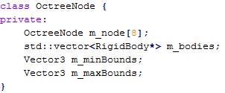

Simply storing the eight child nodes and a list of rigid bodies will suffice, however for ease of use storing the known bounds of the octrees node can also be stored. The above code could also store a parent node, allowing for easy bi-directional traversal of the octree.

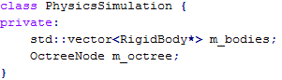

Simply creating an instance of an octree node within the simulation is all that is required.

The public interface for the octree node is also quite simple as the majority of the code lies within the narrow-phase collision detection within the rigid bodies’ themselves. The *checkForCollisions()* method can simply be called on the root of the tree, in doing so all rigid bodies within that node will be checked, then traversing down through the trees nodes, checking only for collisions between bodies’ within that node.

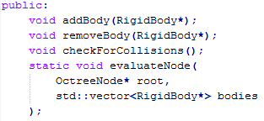

There is also a static method used to evaluate the nodes within the octree. Given an octree node and a list of rigid bodies, said bodies will be added to the relevant octree node based upon the position of the rigid body and the bounds of the octree node. Re-evaluating the entire tree could be an expensive procedure, however checking for collisions against bodies which should no longer be within a given node is also a hindrance to performance. It is a matter of evaluating the tree at a given interval, also rather than evaluating the entire tree, you could also start half way down the tree and split the evaluation into multiple passes. Allowing for parallelisation within the implementation in the future.

**The Sweep and Prune Implementation**

The sweep and prune phase will be implemented within the *checkForCollisions()* method of the octree. The basic principle is to only perform narrow-phase collision detection upon bodies whom have at least one axis which overlaps.

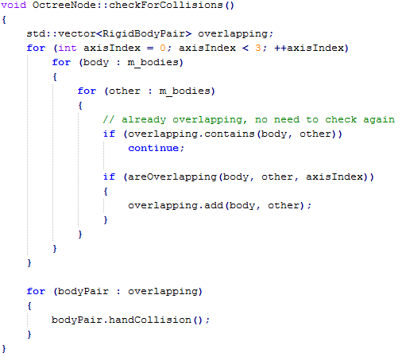

The above algorithm can be improved somewhat as this is performing the check n2 times, but the basic principle of the sweep and prune algorithm is addressed. To improve the algorithm the inner loop should start from the next body in the list from the outer loop, meaning the test is only performed once per rigid body pair.

The check for overlapping method simply returns true (success) should any one of the three world spaces of the rigid bodies overlap.

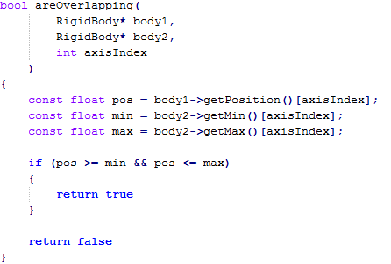

There are multiple ways to check for overlap, the above example is one of them. Another way would be to translate the second body into the first bodies’ world space, allowing easy checking for overlap.

The above is a very simplistic approach to sweep and prune, but due to the potential use of an octree and algorithmic optimizations, the proposed implementation will suffice.

**Example Scenario Estimated Results**

Given a simulation world containing 500 evenly distributed rigid bodies, a simulation with only narrow-phase collision detection and no algorithmic optimizations would require n2 number of collision checks, resulting in 250,000 checks taking place.

Simply adding an octree to the simulation (in an ideal scenario) could reduce the number of checks to 102 × 50 (given a minimum octree nodes size of 10) resulting in only 5000 checks being required. However there is overhead in having to re-evaluate the octree due to the potential ever changing positions of the rigid bodies’.

The algorithm can also be optimized, due to the nature of an n2 algorithm. The n2 algorithm has the overhead of checking if $a and b$ as well as $b and a$. If $a and b$ are colliding then $b and a$ will also be colliding, meaning a pointless check is performed. On top of this the n2 algorithm also performs collision detection against itself, another pointless operation. Performing an algorithmic optimization can reduce the 102 × 50 approximation and reduce it to 45 × 50, which is only 2250 checks (resulting in an estimated 99.0% reduction in checks from the original 250,000).

Finally, adding the sweep and prune algorithm can reduce the need for performing narrow-phase collision. Estimating the reduction in collision checks however is not something that can be calculated accurately.

Depending on the amount of variance within the physical simulation the performance gains will vary. The dynamic octree will need to re-evaluate the bodies within the nodes, should there be a lot of movement within the simulation, moving the bodies about the tree can hinder caching opportunities, as well as computational overhead from re-evaluating the tree.

**Conclusion**

The aim of this paper was to research, compare and propose a solution for broad-phase collision detection within a real-time physics simulation. The majority of current solutions are based around the partition of space, however limitations in doing this exist.

I believe that this paper points out that the future of real-time broad-phase collision detection lies in the area of parallelisation. Modern hardware is designed in such a way that physical simulations could easily reap the benefits of parallelisation, however research within the area is still being collated.

This is the reason I proposed a solution using a hybrid of the octree and sweep and prune algorithms. Although the proposed solution has potential limitations in some scenarios, I believe I have shown it is a simple, generic solution with the potential of vast performance improvements.

**References**

<http://www.brandonpelfrey.com/blog/wp-content/uploads/2013/01/simple-octree.png>

<http://www.cs.berkeley.edu/~demmel/cs267/lecture26/Quadtree2.gif>

[www.inf.ufrgs.br/~comba/papers/2005/sabsp-i3d05.pdf](http://www.inf.ufrgs.br/~comba/papers/2005/sabsp-i3d05.pdf)

Dynamic Adaptation of Broad Phase Collision Detection Algorithms

Efficient Large-Scale Sweep and Prune Methods with AABB Insertion and Removal

Luque, Rodrigo G. (2005). Broad-phase collision detection using semi-adjusting BSP-trees. New York: I3D '05 Proceedings of the 2005 symposium on Interactive 3D graphics and games. p179-186.

Samet, Hanan (1984). The Quadtree and Related Hierarchical Data Structures. New York: ACM Computing Surveys. p187-260.

Moore, Matthew and Wilhelms, Jane (1988). Collision Detection and Response for Computer Animation. New York: SIGGRAPH '88 Proceedings of the 15th annual conference on Computer graphics and interactive techniques. p289-298.

Baraff, D (1992). Dynamic Simulation of Non-Penetrating Rigid Bodies. Cornell University: PhD thesis.

Cohen, J. D, Lin, M. C, Manocha, D. and Ponamgi, M. K (1995). An interactive and exact collision detection system for large-scale environments. Symposium on Interactive 3D Graphics. 189–196, 218.